Key Observations
- Customer 23 = Revenue Leader (33.8% of total active value): 9 orders totalling $115,722. Best job: 396229 ($18,399/0.50h = $36,799/hr). Customer 23 accounts for 33.8% of all active value today.
- Customer 5 = Quote of the Day ($21,866 in 2.35 hrs): Q 395947 is the second-highest value job overall and the highest single quote. At $9,304/hr it is an elite efficiency rating. Watch for conversion to order.
- Customer 16 = Time Sink on Orders: 3 orders consuming 9.90 RM hours for $9,724 combined. O 395916 (IP/WIP, 4.45 hrs) and O 395915 (5.00 hrs) are the two biggest time consumers of the day, yielding only $982/hr combined. Multi-part jobs warranting process review.
- Actual 49.12 hrs vs 40-hr baseline = 122.8% load. 10 orders left Pending (NA), 2 still In Progress (IP). Any backlog on high-value customers represents significant deferred revenue risk.

Assumptions
- All tasks were completed assuming continuous, stable access to the client’s remote desktop server (remote.stainlessdesign.co.nz).
- The master data and pricing within the client's Quoting System are current and accurate.
- Provided source files are compatible with the team’s AutoCAD/SolidWorks environment.
- The technical specifications, drawing dimensions, and instructions provided in the RM Notes or via FTP attachments were complete and final at the time of assignment.
- Processing followed the most recent SDL Standard Operating Procedures (SOPs) provided; it is assumed no undocumented procedural changes were in effect during the shift.
- Any critical clarifications requested via email (ataul.morshed@entopbd.com) were addressed promptly to allow for completion within the day.

Deliverable materials
Deliverable work products include:
- Digital part and drawing files processed via AutoCAD and SolidWorks.
- Updated project folders on the client’s FTP server containing all associated attachments for Quotations and Orders.
- Standardized electronic quotes and production orders finalized within the customer's remote database.
- Processed Estimates: Comprehensive cost data entered directly into the Quoting System.
- CAD Data & Part Files: Processed DWG, DXF, PDFs, SLDDRW, SLDPRT, IGS, and STP/STEP files prepared using AutoCAD and SolidWorks.
- Project Data: Completed estimates entered in the Quoting System. Job-specific notes documented within the Notes section of each Quote/Order in RM web app.
- Daily Status Report: Daily workload summary delivered by 8 AM NZ Time the following working day.

Completion criteria
Meaning of different completion status
- Complete = The assignment was completed and delivered to the fullest extent of our understanding.
- In Progress = The assignment was not completed at the time this report was prepared. Incomplete deliverables can be provided upon request.
- Not attempted = The assignment could not be started due to a lack of time and workforce.
- Given up = The assignment was abandoned mid-production due to misunderstandings, missing information, lack of tools, or other valid reasons.
- Ignored = The assignment was ignored at the customer's request due to other priorities or reasons they deemed suitable, or due to our lack of know-how, training, skills, and infrastructure.
- All assigned Quotations and Orders for the day are fully processed in the Quoting System.
- All necessary notes are recorded in Resource Manager, and all associated files are successfully uploaded to the FTP server.
- The work satisfies the quality standards defined in the current SDL SOPs.
The final report is submitted prior to the following working day 8 AM NZ Time deadline. The Contractor confirms that all assigned deliverables for DWR# 2026-XX have been processed and uploaded as detailed in this summary.
 |  |  | For | Contractor
 |  |  | Name: | Mohammad Ataul Morshed
 |  |  | Signature: | 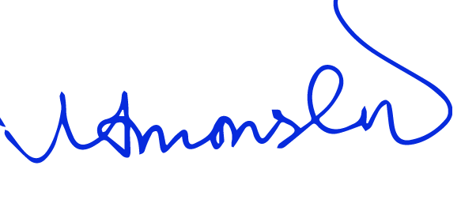
 |  |  | Title: | Director, Sales & Operations

